Software Requirements Specification (SRS)

Placement Management System (PMS)

1. Introduction
Managing campus placements is often difficult due to manual processes, lack of transparency, and poor coordination between students and the placement cell. Students face confusion about job opportunities and application status, while placement departments struggle with managing company requirements and schedules.
This project proposes a Placement Management System (PMS)—a web-based platform that automates and centralizes the entire placement process. It allows easy job postings, eligibility checking, application tracking, interview scheduling, and notifications.
The system reduces time, improves communication, and provides a reliable and efficient solution for campus placement management.

1.1 Purpose
The purpose of this Software Requirements Specification (SRS) document is to provide a detailed and structured description of the requirements for the Placement Management System (PMS). This document serves as a formal reference for understanding the system’s functionality, operational constraints, and performance expectations.
The SRS acts as a baseline agreement between stakeholders, placement administrators, developers, and evaluators, ensuring that the system is designed and implemented in accordance with clearly defined requirements. It also supports system validation, testing, and future enhancements by documenting both the functional and non-functional requirements of the Placement Management System.

1.2 Document Conventions
This document follows the IEEE-830 Software Requirements Specification standard and uses the following conventions:
- Section numbering is based on IEEE-830 guidelines
- Functional requirements are labelled as FR-#
- Non-functional requirements are labelled as NFR-#
- The keyword “shall” indicates a mandatory system requirement
- The keyword “may” indicates optional functionality
- Technical terms are used consistently throughout the document

1.3 Intended Audience and Reading Suggestions
- Students – to view job opportunities, apply for placements, track application status, and receive updates
- Placement Coordinators – to manage company postings, student eligibility, interview schedules, and overall placement activities

1.4 Project Scope
The Placement Management System (PMS) is a web-based application that automates campus placement activities in colleges and universities. It provides a centralized platform for managing student profiles, job and internship postings, eligibility checking, applications, interview schedules, and placement results.
Students can register, upload resumes, apply for eligible opportunities, and track their application status. Placement coordinators can post opportunities, manage eligibility, shortlist students, schedule interviews, and update placement outcomes.
The system includes secure authentication, role-based access, database integration ensuring an efficient and scalable placement management solution.

1.5 References
[1] IEEE Std 830‑1998 — Software Requirements Specifications
[2] IEEE Std 1016‑2009 — Software Design Descriptions
[3] Organization Security & Compliance Policies

2. Overall Description
This section provides a high-level description of the Placement Management System (PMS), including its operational context, core functionalities, user roles, operating environment, and system constraints.

2.1 Product Perspective
The Placement Management System (PMS) is a web-based, client–server application designed to automate and manage campus placement activities within educational institutions. The system consists of a centralized backend server and role-based client interfaces for students and placement administrators, communicating through secure REST APIs.
The application operates as an independent system and provides functionalities such as student profile management, job and internship postings, eligibility verification, application processing, interview scheduling, announcements, and placement status management. The PMS does not rely on external enterprise platforms and is designed to be scalable and platform-independent.

2.2 Product Functions
- Student registration and secure login
- Student profile creation and management
- Resume upload and management
- Viewing job and internship opportunities
- Automatic eligibility verification for applications
- Job and internship application processing
- Interview scheduling and management
- Placement announcements and notifications
- Offer letter management and download
- Student query handling and communication

2.3 User Classes and Characteristics
- Administrator (Placement Cell) — Manages companies, job postings, student data, applications, interviews, and placement outcomes.
- Students — Maintain profiles, apply for jobs and internships, track status, and receive placement updates.

2.4 Operating Environment
- Web browser-based user interface
- Backend server developed using Node.js (Express)
- MongoDB NoSQL database
- Local or cloud-hosted deployment

2.5 Design and Implementation Constraints
- Must comply with institutional data security and privacy policies
- Must implement role-based access control for students and administrators
- Must support secure authentication and authorization mechanisms
- Must be scalable to handle multiple batches and companies
- Must operate within web-based and cloud-compatible environment

2.6 User Documentation
- System usage guide
- API documentation
- Installation and configuration guide

2.7 Assumptions and Dependencies
- Users have access to reliable internet connectivity
- Students and administrators possess valid login credentials
- The institution provides accurate student and placement data
- Availability of email or notification services for communication
- Proper server infrastructure and database services are maintained

3. System Features (Functional Requirements)

FR-1 User Registration and Authentication
- The system shall allow students to register and log in using secure credentials.
- The system shall allow administrators to log in with authorized access.

FR-2 Student Profile Management
- The system shall allow students to create and update personal and academic profiles.
- The system shall allow students to upload and manage resume documents.

FR-3 Company and Job Management
- The system shall allow administrators to add, update, and delete company details.
- The system shall allow administrators to post job and internship opportunities.

FR-4 Eligibility Verification
- The system shall automatically verify student eligibility based on predefined criteria.
- The system shall restrict job applications for ineligible students.

FR-5 Job and Internship Application
- The system shall allow eligible students to apply for job and internship opportunities.
- The system shall prevent duplicate applications for the same opportunity.

FR-6 Application Status Management
- The system shall allow administrators to shortlist, reject, or select students.
- Students shall be able to view their application status in real time.

FR-7 Interview Scheduling
- The system shall allow administrators to schedule interviews.
- Students shall be able to view interview schedules and related details.

FR-8 Announcements and Notifications
- The system shall allow administrators to publish placement announcements.
- The system shall notify students of placement-related updates.

FR-9 Offer and Placement Status Management
- The system shall allow administrators to manage offer letters and placement status.
- Students shall be able to view and download offer letters.

FR-10 Query Management
- The system shall allow students to submit queries to the placement cell.
- The system shall allow administrators to view and respond to student queries.

FR-11 Data Persistence and Security
- The system shall store student, company, job, and application data securely.
- The system shall preserve records for reporting and future reference.

FR-12 System Monitoring
- The system shall provide administrators with visibility into student applications and placement progress.
- The administrator shall be able to monitor system usage and status.

4. External Interface Requirements

4.1 User Interfaces
- Web-based interface displaying job and internship postings for students and administrators
- Separate sections for profile management, applications, interviews, and announcements
- Responsive design supporting both desktop and mobile devices

4.2 Hardware Interfaces
- Standard desktop and laptop computers
- Mobile devices such as smartphones and tablets
- No specialized hardware required

4.3 Software Interfaces
- Backend services accessed through RESTful APIs
- Database management system for persistent data storage

4.4 Communication Interfaces
- Secure communication using HTTPS protocol
- Internet-based data exchange between client and server

5. Non‑Functional Requirements

NFR‑1 Performance
- The system shall respond to user requests within acceptable time limits under normal load.
NFR‑2 Security
- The system shall ensure secure authentication and protect sensitive user data.
NFR‑3 Reliability
- The system shall provide consistent and reliable access during placement activities.
NFR‑4 Usability
- The system shall be easy to use with a simple and intuitive user interface.
NFR‑5 Scalability
- The system shall support an increasing number of users, jobs, and applications.
NFR‑6 Maintainability
- The system shall be easy to maintain and update with minimal downtime.
NFR‑7 Portability
- The system shall be deployable on different environments such as local servers or cloud platforms.

6. System Architecture Overview
Layered Architecture of the Placement Management System

6.1 Presentation Layer
This layer represents the user interface of the Placement Management System.
Students and placement administrators interact with the system through web pages such as Login and registration pages Job and internship listings, Profile, application, interview, and announcement sections

6.2 Business Logic Layer
This layer handles the core functionality of the system.
It processes all requests coming from the frontend and applies system rules such as User authentication and authorization, Eligibility checking before job application, Application submission and status updates, Interview scheduling and offer management

6.3 Data Layer
This layer is responsible for data storage and retrieval.
MongoDB stores information such as Student profiles and resumes, Company and job details, Applications, interviews, and placement records

6.4 Integration Layer
This layer enables communication with external services.
It supports Email notifications for job postings, interviews, and offers, Authentication services, API communication between frontend and backend

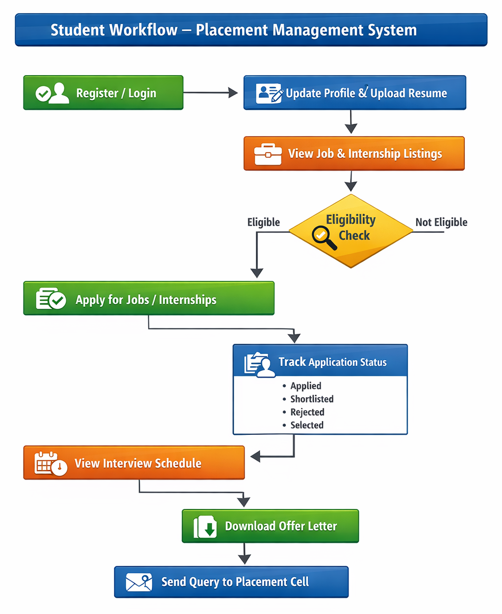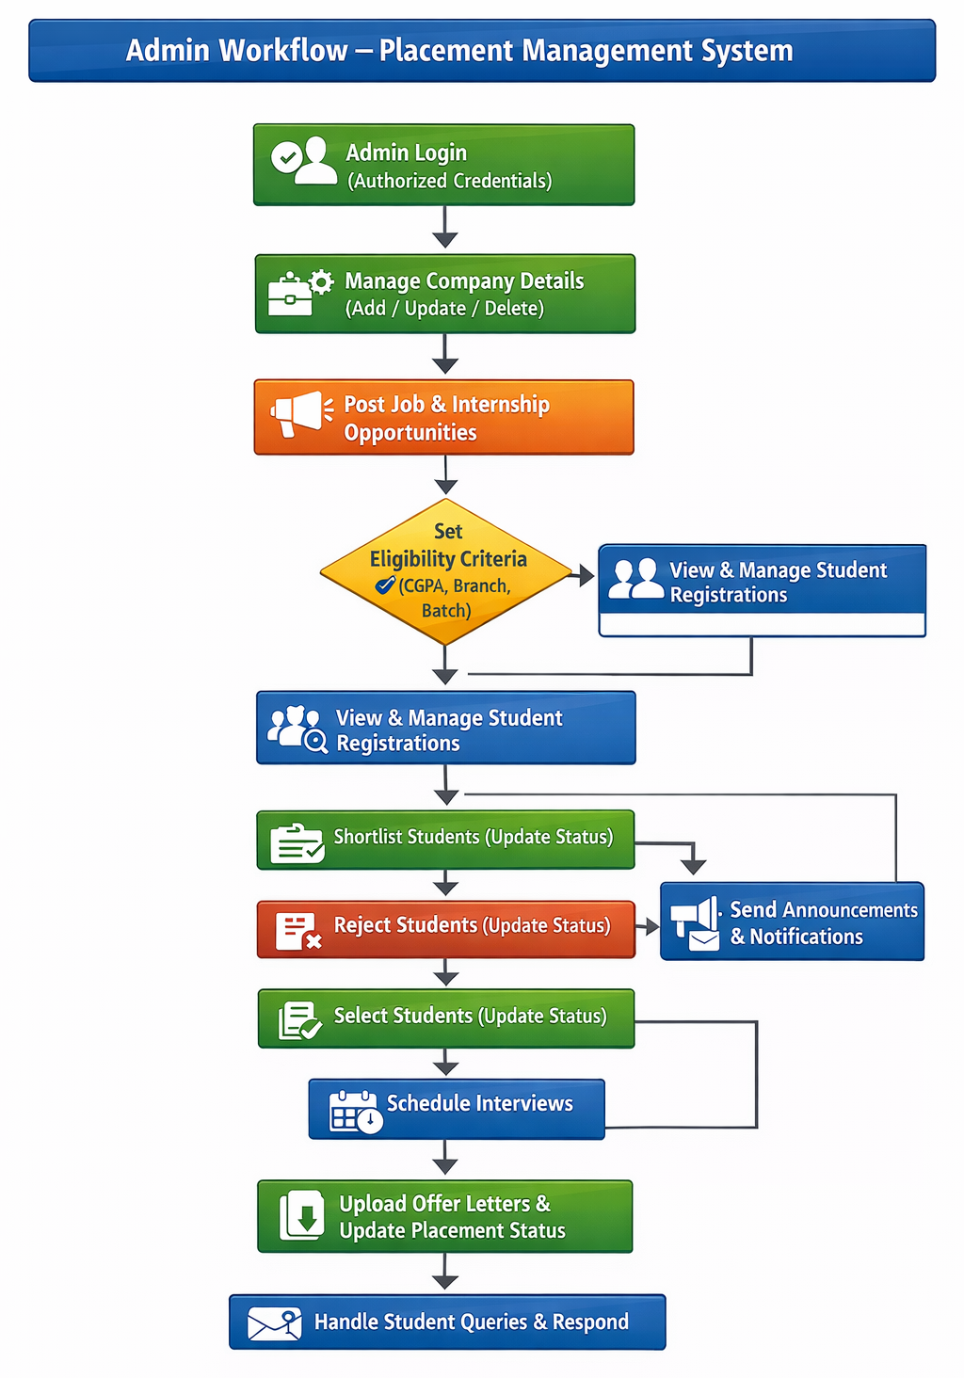

7. System and Data Models (Placeholder)
This section describes the system models used to represent the structure, behavior, and data organization of the Placement Management System (PMS). These models provide a clear understanding of component interactions and data flow throughout the placement process. Multiple modeling techniques are used to capture both functional behavior and data relationships.

7.1 System Architecture Model
The System Architecture Model illustrates the layered design of the PMS, including the presentation layer, business logic layer, data layer, and integration layer. It highlights the interaction between user interfaces and backend services while maintaining separation of responsibilities.

7.2 Data Model
The Data Model defines the structure of the database used by the system. Key entities include students, administrators, companies, job and internship postings, applications, interviews, and placement records. Relationships among these entities ensure accurate data storage, consistency, and reliable retrieval.

7.3 Workflow Model
The Workflow Model represents the sequence of placement activities, including student registration, job posting, eligibility checking, application submission, shortlisting, interview scheduling, and offer management. It helps visualize system operations and data flow.

7.4 UML Diagrams
Unified Modeling Language (UML) diagrams are used to represent system interactions and behavior at a conceptual level. These diagrams support understanding of system flow and user interactions without focusing on implementation details.
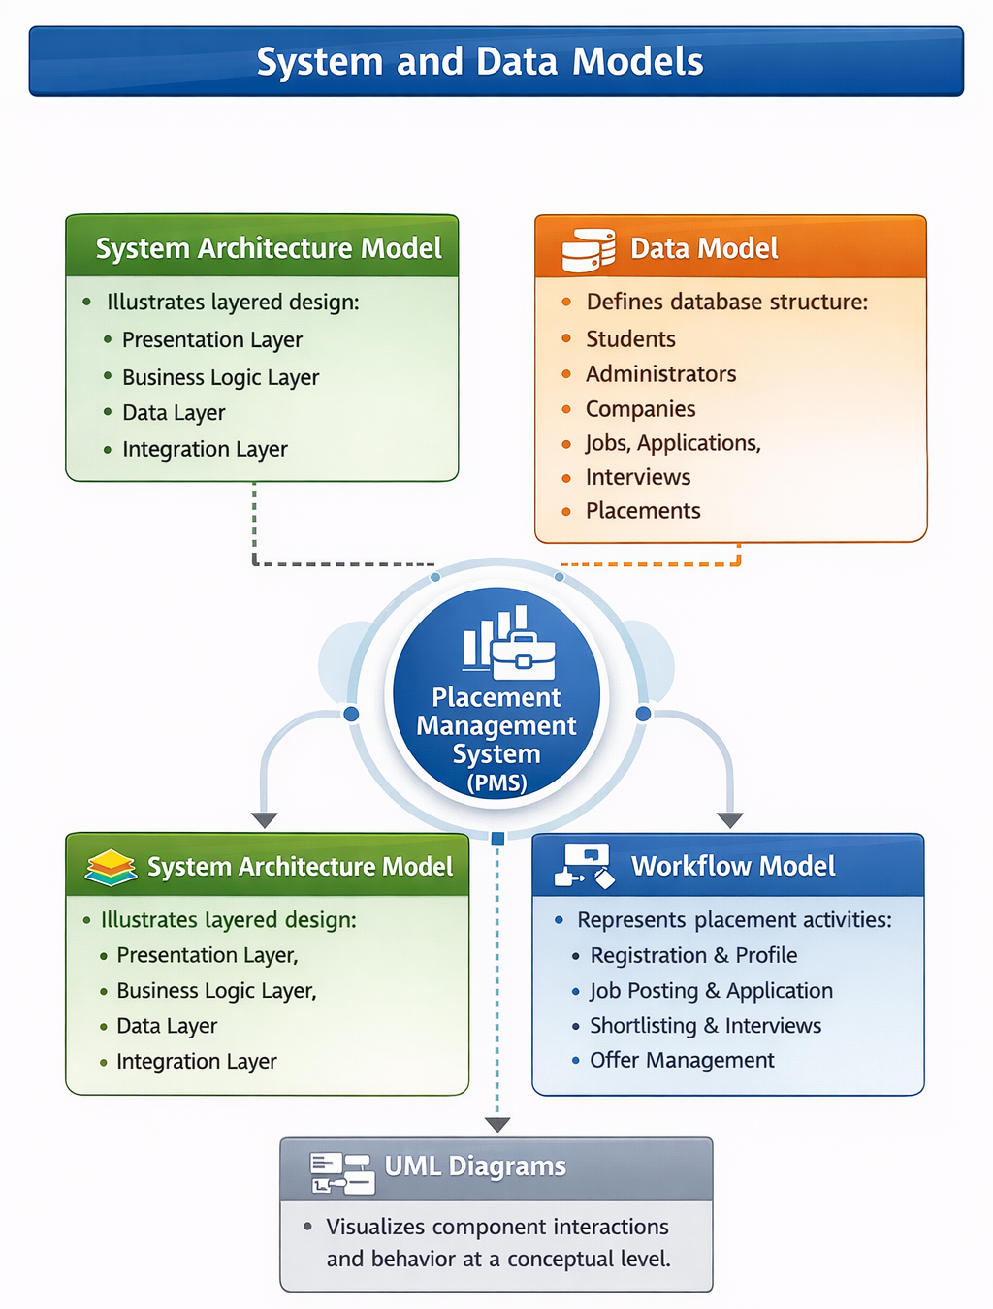

8. Validation and Acceptance Criteria
- All functional requirements of the Placement Management System shall be validated through defined test cases.
- Each system feature shall be tested to ensure it performs according to the specified requirements.
- User Acceptance Testing (UAT) shall be conducted with placement administrators and student users.
- The system shall be accepted only after successful completion of functional, security, and performance testing.
- All identified defects must be resolved and retested before final approval.

9. Appendices

Appendix A: Glossary
Defines key terms and abbreviations used in the Placement Management System, such as PMS, Administrator, Student, Job Posting, Eligibility Criteria, and Placement Status.
Appendix B: Sample Data
Provides sample records for students, companies, job and internship postings, applications, interview schedules, and offer details used for testing and demonstration purposes.
Appendix C: Compliance Checklist
Lists security, privacy, and institutional compliance requirements to ensure the system adheres to organizational and academic standards.

